**Status Epilepticus**

**Status Epilepticus Introduction**

Status epilepticus is a serious neurological emergency characterized by prolonged or recurrent seizures without a return to baseline consciousness in between events. It affects approximately 150,000 to 200,000 people in the United States each year and has a mortality rate of up to 20%. Rapid recognition and treatment are critical, as the longer the duration of status epilepticus, the more difficult it becomes to terminate seizures and prevent long-term consequences. Pharmacists play a vital role on the interprofessional team in optimizing medication selection, dosing, monitoring, and continuity of care for these complex patients.

Definitions

* Seizure
  + Generally last <2 minutes
* Old Status Epilpeticus Defitinition
  + Any seizure lasting ≥ 30 min.
* New Definition (2015)
  + Any seizure lasting ≥ 5 min.
  + ≥ 2 seizures w/o return to baseline

[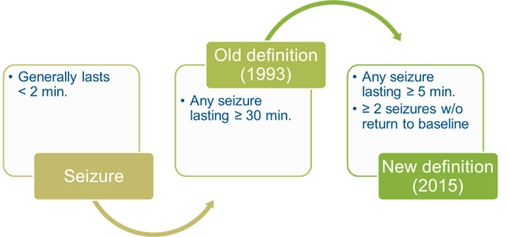](https://files.synap.ac/production/xgu3DOMWgP/2snkFsNQdKFFmRzNyRaQ_image.png)

**Clinical Presentation**

The clinical presentation of status epilepticus can be divided into early and late signs and symptoms. Seizure semiology, mental status changes, vital sign abnormalities, and potential complications reflect the progression of this dynamic disease state.

Symptoms:

* Impaired consciousness ranging from confusion to coma
* Amnesia for the seizure
* Muscle contractions and unusual body movements
* Involuntary passage of urine or feces

Early signs:

* Generalized convulsions with rigidity and jerking
* Tongue biting, head/eye deviation
* Injuries related to seizures like head trauma, shoulder dislocations
* Low grade fever may be present

Late signs:

* Ongoing seizures may progress to subtle muscle twitching or eye deviation
* Post-ictal state with unresponsiveness, lethargy, sleepiness
* Respiratory failure requiring intubation and mechanical ventilation
* Hemodynamic instability - hypotension, arrhythmias
* Hyperthermia from excessive muscle activity
* Rhabdomyolysis and myoglobinuria
* Aspiration pneumonia, pulmonary edema
* Metabolic derangements like lactic acidosis, hypoglycemia

Risk factors:

* History of epilepsy - especially uncontrolled seizures
* Prior episodes of status epilepticus
* Recent changes in antiseizure regimen
* Medication non-adherence
* Alcohol or sedative withdrawal
* Metabolic disorders like renal failure, liver failure
* CNS infections like meningitis, encephalitis
* Stroke, CNS tumor, head trauma
* Drug overdose, toxin exposure

The progression of status epilepticus from early generalized convulsions to subtle seizure manifestations and post-ictal impairment along with the potential for systemic complications underscore the need for prompt recognition and treatment.

[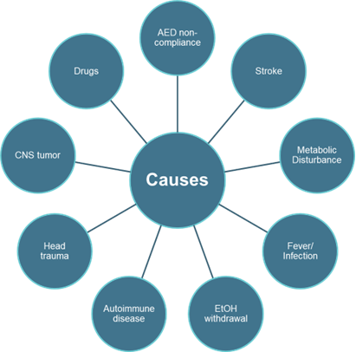](https://files.synap.ac/production/xgu3DOMWgP/wthLW6h1SMGW0jYWrHyT_image.png)

**Pathophysiology**

Status epilepticus occurs when mechanisms that normally terminate seizure activity fail, leading to abnormally prolonged neuronal excitation. The exact pathophysiology is not fully elucidated but is thought to involve:

* Imbalance between excitatory (glutamate) and inhibitory (GABA) neurotransmission
* Changes in synaptic receptor trafficking - internalization of GABAA receptors, increased NMDA receptors
* Sustained depolarization from glutamate acting on NMDA and AMPA receptors
* Systemic effects from prolonged ictal activity like metabolic acidosis, rhabdomyolysis, hyperthermia

With increasing duration of seizures, pharmacoresistance develops due to changes in receptor dynamics. Prolonged status epilepticus also leads to neuronal injury, likely through excitotoxicity, oxidative stress, and inflammation.

**Diagnostic Approach**

Status epilepticus represents a clinical diagnosis based on observation of prolonged seizure activity, with neurodiagnostic and laboratory testing aimed at identifying etiology, complications, and prognosis.

Detailed history and physical examination focusing on:

* Seizure duration, type, and timing
* Presence of aura or triggers
* Mental status before, during, and after seizures
* Medication history, drug/alcohol use
* Evidence of trauma, infections

Diagnostic criteria:

* Clinical diagnosis - seizure lasting >5 minutes or recurrent seizures without full recovery between events
* EEG - epileptiform discharges persisting for >30 minutes

Laboratory tests:

* Complete blood count, electrolytes, renal function tests, liver function tests, calcium, magnesium
* Toxicology screen, antiseizure drug levels
* Blood cultures, plasma lactate
* Urinalysis for myoglobin, infectious studies as needed

Neuroimaging:

* Non-contrast CT to assess for acute brain injury
* MRI brain with contrast to evaluate for underlying structural lesions
* CT or MR angiography if vascular cause suspected

EEG:

* Mandatory to confirm seizures and monitor treatment response
* Helps distinguish clinical versus electrographic seizures
* Identifies seizure focus and classifies subtype of status epilepticus

Lumbar puncture if CNS infection suspected

Additional testing guided by suspected etiology: autoimmune panels, metabolic studies, genetic testing

The combination of clinical evaluation, EEG, neuroimaging, and laboratory assessment facilitate rapid diagnosis of status epilepticus, allowing initiation of targeted treatment to improve outcomes.

### Status Eptilepticus Management – Overview

The primary goals are rapid termination of seizure activity, prevention of recurrence, minimizing systemic complications, and treatment of precipitating causes. A stepwise approach is utilized based on seizure duration, starting with emergent antiseizure medications, then escalating to anesthetics if needed. Supportive care, continuous EEG monitoring, treatment of underlying etiologies, and prevention of complications are key elements of management.

[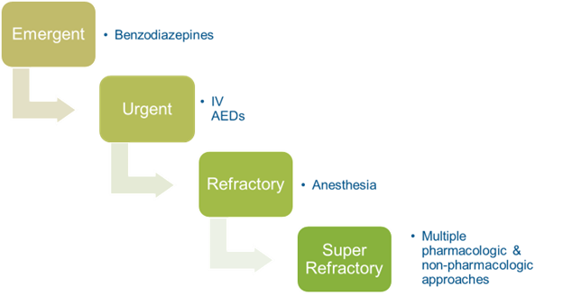](https://files.synap.ac/production/xgu3DOMWgP/oRnKyVxiSDu4rPLz8uqz_image.png)

### Status Eptilepticus Pharmacotherapy

#### Emergency management of impending status epilepticus (0-5 min):

First line:

* IV lorazepam 0.1 mg/kg (maximum 4 mg/dose)
  + Onset: 5-10 min, duration 6-12 hours
  + High affinity benzodiazepine with rapid onset and longer duration than diazepam
  + Preferred first-line agent in adults and children
* IV diazepam 0.15-0.2 mg/kg (maximum 10 mg/dose)
  + Onset: 1-5 min, duration 15-30 min
  + Useful if lorazepam unavailable but higher recurrence due to shorter duration

May repeat above doses once after 5 minutes if seizures persist

* Alternatives if no IV access:
  + IM midazolam 10 mg in adults, 5 mg in children >40 kg, 0.2 mg/kg in children <40 kg
    - Onset: 5-15 minutes
    - Effective absorption by IM route
    - Repeat dosing every 5 minutes may be required (maximum 40 mg)
  + IN midazolam 0.2 mg/kg
    - Onset: 3-5 minutes
    - Maximum 10 mg per dose
  + Similar bioavailability to IV route

[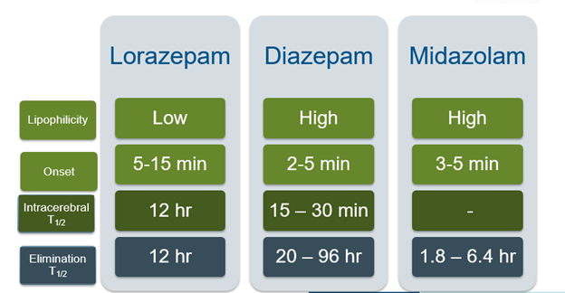](https://files.synap.ac/production/xgu3DOMWgP/49w6uLeqTIaJQH24wWUf_image.png)[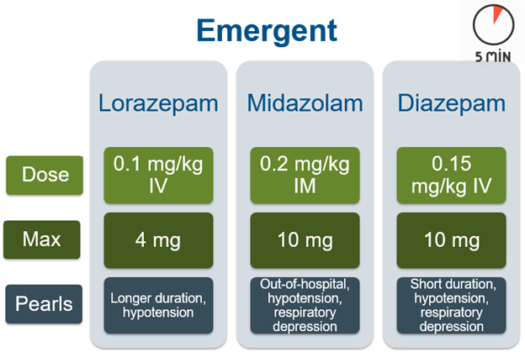](https://files.synap.ac/production/xgu3DOMWgP/HFCmYo4wRpSUNjeyGiMz_image.png)

* **Supportive care:**
  + Airway protection
  + Oxygenation and ventilation support
  + Continuous monitoring of respiratory status
  + IV access
  + Check fingerstick glucose; treat hypoglycemia with dextrose
  + Consider thiamine 100 mg IV in at-risk alcohol withdrawal patients
  + Emergent brain imaging if evidence of acute structural injury

#### **Established convulsive  status epilepticus (5-30 min):  Urgent**

#### **IV fosphenytoin**

* Loading dose: 15-20 mg/kg phenytoin equivalents (PE)
* Max rate: 150 mg PE/min in adults, 3 mg/kg/min (max 150 mg/min) in pediatrics
  + Phentoin: maximum of 50 mg/min infusion rate
* Active metabolite of phenytoin with improved tolerability
* Add on to benzodiazepines for sustained antiseizure effect
* Monitor for hypotension, arrhythmias
* Drug Interactions
  + CYP450 inducer, highly protein bound
    - ↓ concentration of other AEDs, warfarin, contraceptives & many other drugs
* Adverse effects
  + Infusion reaction
  + Purple glove
  + Teratogenic
* Therapeutic Drug Monitoring:
  + Draw 2 hours after LD
  + Total: 10-20 mcg/mL
  + Free (unbound): 1.0-2.0 mcg/mL

#### **IV valproic acid**

* Loading dose: 20-40 mg/kg
  + May give an additional 20 mg/kg 10 min after LD
* Broad spectrum antiseizure activity
* Well tolerated hemodynamically
* Therapeutic trough: 50-125 mcg/mL
* Drug Interactions
  + CYP450 inhibitor, highly protein bound
  + Other AEDs (including phenytoin), carbapenems & many others
* Adverse Effects
  + Dose-dependent thrombocytopenia
  + Hepatoxicity
  + Hyperammonemia
  + Encephalopathy
  + Pancreatitis
  + Avoid in pregnancy

#### IV levetiracetam

* Loading dose: 40-60 mg/kg (maximum 4500 mg) over 5-15min
* Maintenance: 1000-3000 mg every 12 hours
* Favorable adverse effect profile
  + Agitation
  + Thrombocytopenia (rare)
  + Pregnancy Category C
* Lacks drug-drug interactions

#### Other medications:

* Loading dose phenobarbital 15-20 mg/kg
* Consider pyridoxine 100 mg IV in children

Monitoring:

* Continuous cardiac monitoring
* Repeat antiseizure drug levels every 6 hours and after each loading dose
* Serum glucose q1-2h
* Continuous EEG monitoring
* Prevent systemic complications like rhabdomyolysis, hyperthermia

[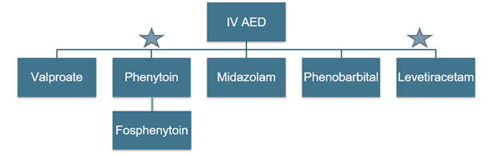](https://files.synap.ac/production/xgu3DOMWgP/9exd7HrHSR2Z7SqeICQC_image.png)

#### Refractory status epilepticus (fail 2 drugs, >30 min):

[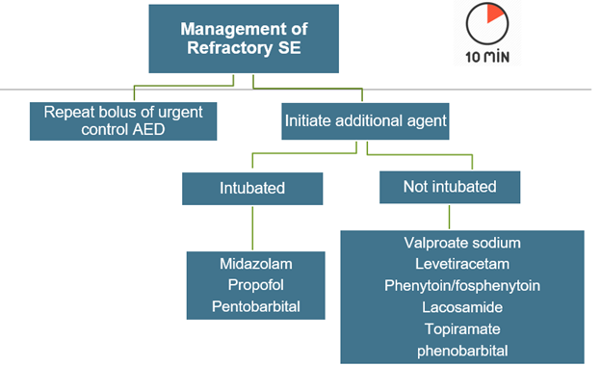](https://files.synap.ac/production/xgu3DOMWgP/XDG80s9Tuv9b7mGK01EQ_image.png)

[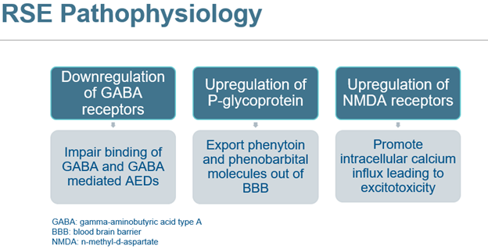](https://files.synap.ac/production/xgu3DOMWgP/ZcIDUeyRKuAJnAzdMWPg_image.png)

**IV anesthetics:**

#### Propofol

* Propofol bolus 1-2 mg/kg, infusion 20-200 mcg/kg/min, titrated to burst suppression on EEG
* Rapid onset and offset makes titration feasible
* Risk of propofol infusion syndrome with prolonged high doses
* Few drug interactions
* Hypotension

#### Midazolam

* Bolus 0.2 mg/kg, infusion 0.05-3 mg/kg/hour
* Titrate by ↑ 0.05 – 0.1 mg/kg/hr  q3-4 hr
  + Generally, a period of at least 24 hours of electrographic suppression is suggested prior to down titrating the continuous infusion; withdraw gradually by decreasing the dose 50% every 3 hours to prevent recurrent status epilepticus
* Short-acting benzodiazepine, lower risk of accumulation
* Hypotension common, especially with rapid infusion
* Advantages
  + No propylene glycol
  + Less hypotension
* Disadvantages
  + Respiratory  depression
  + Tachyphylaxis (24 - 48 hr)
  + Prolonged sedation

#### Pentobarbital

* bolus 5-15 mg/kg, infusion 0.5-5 mg/kg/hour
* Titrated to attain burst suppression pattern on EEG monitoring
* Risk of prolonged respiratory depression
* Disadvantages
  + Lowers  body temperature
  + Can accumulate in adipose
  + Hypotension
  + Cardio-respiratory depression
  + Drug interactions
  + CYP450 inducer
  + ↓ concentration of other AEDs, warfarin, contraceptives & many other drugs

#### Ketamine

* Bolus:  1 – 2 mg/kg
* CI: 0.45 – 2.1 mg/kg/hr
* Advantages
  + Unique MOA
  + Favorable side effects
  + Minimal respiratory depression
  + Hemodyanamic favorable (increase BP and HR)
* Disadvantages
  + Little Data
  + Emergence delirium

#### Non-anesthetic options:

* IV lacosamide 200-400 mg, maximum 600 mg/day
* Oral topiramate 600 mg daily in divided doses
* Treatment of underlying etiology
* Evaluation for autoimmune epilepsy if suspected
* Continuous EEG monitoring is mandatory

**Key principles:**

* Median time to seizure control is between 1-2 hours
* Risk of systemic complications and mortality increases after 30 min of status epilepticus
* Multimodal therapy usually required for refractory cases
* Individualize therapy based on comorbidities and hemodynamic status
* Target upper end of goal antiseizure levels when using chronic medications
* Prepare to treat systemic complications like hyperthermia, rhabdomyolysis, acidosis

### Status Eptilepticus Key Guidelines and Evidence

#### Treatment of Convulsive Status Epilepticus in Children and Adults: Report of the Guideline Committee of the American Epilepsy Society. (2016)

Recommendations:

* Initial Therapy (Level A): The first-line treatment for convulsive SE in adults and children should be a benzodiazepine. This can be administered as intravenous lorazepam, intramuscular midazolam, or intravenous diazepam.
* Established Seizures (Level A): If seizures persist after initial therapy, second-line treatment should be initiated. This can include intravenous fosphenytoin, valproate, levetiracetam, or phenobarbital.
* Refractory Seizures (Level A): If seizures continue after second-line treatment, the patient should be treated for refractory SE. This typically involves the use of continuous infusion anesthetics such as midazolam, propofol, or barbiturates.
* Non-IV Therapy (Level B): If intravenous access is not available, intramuscular midazolam is recommended as the most effective non-intravenous therapy.
* Super-Refractory SE (Level U): There is insufficient evidence to support or refute specific treatments for super-refractory SE. Treatment should be individualized and may include immunotherapy, ketogenic diet, or electroconvulsive therapy.

#### Landmark Trials:

* Veterans Affairs Cooperative Trial compared phenytoin, valproate, phenobarbital, and lorazepam for initial treatment of status epilepticus. As initial intravenous treatment for overt generalized convulsive status epilepticus, lorazepam is more effective than phenytoin. Although lorazepam is no more efficacious than phenobarbital or diazepam plus phenytoin, it is easier to use.
* ESETT Trial found that levetiracetam was not superior to fosphenytoin for established status epilepticus but had fewer side effects.

**Clinical Scenarios**

Clinical Scenario 1:

* Case: A 65-year-old male with a history of hypertension and alcohol use disorder experiences a generalized tonic-clonic seizure lasting over 7 minutes. Despite receiving lorazepam 4 mg IV by EMS, he remains unresponsive and seizes again upon hospital arrival. Fosphenytoin 15 mg/kg IV is administered, but his seizures persist 30 minutes post-arrival.

* Question: What does the continued seizure activity after administering first and second-line agents indicate about the progression of the patient's condition?

* Answer: The patient's continued seizure activity indicates that he is experiencing refractory status epilepticus.

* Explanation: Status epilepticus is a medical emergency characterized by prolonged seizures or frequent seizures without recovery in between. Its progression is categorized into three phases: impending, established, and refractory. The patient's seizures, despite treatment with both lorazepam (a first-line agent) and fosphenytoin (a second-line agent), suggest he has entered the refractory phase. This phase requires urgent escalation to anesthetic agents, as prolonged seizures can lead to severe complications, including brain damage or death.

Clinical Scenario 2:

* Case: A 22-year-old female with a history of epilepsy, managed with levetiracetam, presents with generalized tonic-clonic seizures. Upon checking her levetiracetam levels, they are found to be undetectable.

* Question: What does the undetectable level of levetiracetam suggest about the patient's medication management?

* Answer: The undetectable levetiracetam level suggests medication nonadherence.

* Explanation: Levetiracetam is an antiseizure medication, and an undetectable level in a patient with a known history of epilepsy indicates that she might not have been taking the medication as prescribed. Nonadherence can arise from various factors, including side effects, forgetfulness, or intentional skipping of doses. Ensuring consistent medication levels is crucial for managing epilepsy, and addressing nonadherence is vital for preventing future episodes of status epilepticus and improving overall patient outcomes.

**Tips for Board Exam Questions**

Understand the Clinical Stages and Corresponding Treatment: The BPS exam places a significant emphasis on patient care and management, which includes understanding the clinical stages of status epilepticus and the corresponding treatment algorithm. A common mistake is not being able to correctly identify the stage of status epilepticus and the appropriate treatment. Remember, initial treatment involves benzodiazepines, followed by second-line agents if seizures persist, and then continuous infusion anesthetics for refractory status epilepticus.

Adverse Effects and Monitoring: Another area that often trips candidates up is the adverse effects and monitoring parameters of the drugs used in the management of status epilepticus. Each antiepileptic drug has potential adverse effects and requires specific monitoring. For example, benzodiazepines can cause respiratory depression, and fosphenytoin can lead to cardiovascular complications.

**Status Epilepticus Summary**

Status epilepticus is characterized by prolonged seizures and requires emergent management to halt neuronal excitation, prevent systemic complications, and reduce neuronal injury. Key aspects include rapid escalation of antiseizure therapies from benzodiazepines to anesthetics if needed and addressing precipitating causes. Close monitoring of respiratory, hemodynamic, and neurological status is critical. Long-term management focuses on adherence, lifestyle modification, and preventing recurrence.

**References**

* Betjemann JP, Lowenstein DH. Status Epilepticus in Adults. Lancet Neurol. 2015;14(6):615-624. doi:10.1016/S1474-4422(15)00042-3.
* Glauser T, Shinnar S, Gloss D, et al. Evidence-Based Guideline: Treatment of Convulsive Status Epilepticus in Children and Adults: Report of the Guideline Committee of the American Epilepsy Society. Epilepsy Curr. 2016;16(1):48-61. doi:10.5698/1535-7597-16.1.48.
* Trinka E, Kälviäinen R. 25 years of advances in the definition, classification and treatment of status epilepticus. Seizure. 2017;44:65-73. doi:10.1016/j.seizure.2016.11.001.
* Brophy GM, Bell R, Claassen J, et al. Guidelines for the evaluation and management of status epilepticus. Neurocrit Care. 2012;17(1):3-23. doi:10.1007/s12028-012-9695-z.
* Meierkord H, Boon P, Engelsen B, et al. EFNS guideline on the management of status epilepticus in adults. Eur J Neurol. 2010;17(3):348-355. doi:10.1111/j.1468-1331.2009.02917.x.
* Silbergleit R, Durkalski V, Lowenstein D, et al. Intramuscular versus intravenous therapy for prehospital status epilepticus. N Engl J Med. 2012;366(7):591-600. doi:10.1056/NEJMoa1107494.
* Kapur J, Elm J, Chamberlain JM, et al. Randomized Trial of Three Anticonvulsant Medications for Status Epilepticus. N Engl J Med. 2019;381(22):2103-2113. doi:10.1056/NEJMoa1905795.
* Treiman DM, Meyers PD, Walton NY, et al. A comparison of four treatments for generalized convulsive status epilepticus. Veterans Affairs Status Epilepticus Cooperative Study Group. N Engl J Med. 1998;339(12):792-798. doi:10.1056/NEJM199809173391202.
* Lowenstein DH, Alldredge BK. Status epilepticus. N Engl J Med. 1998;338(14):970-976. doi:10.1056/NEJM199804023381407.